**KAJJANSI HIGH SCHOOL**

**SET 2 ASSESSMENTS 2024**

**GEOGRAPHY S.2**

**TIME: 11/2 HOURS**

**INSTRUCTIONS**

* Attempt **ALL** questions

1. Uganda is a land locked country in Eastern Africa, west of Kenya, south of South Sudan, east of DRC and north of Rwanda and Tanzania. All this information is known well when one has got geographical knowledge. Therefore as an inspiring geographer;

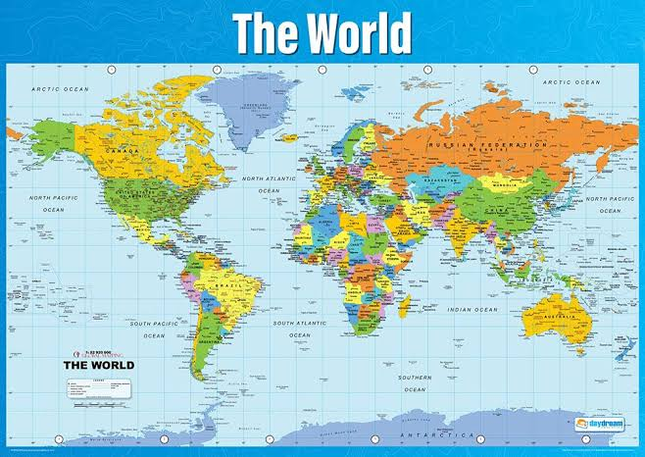**Support material**

1. What do you understand by the term **“Geography”**? (01 mark)

..................................................................................................................................................................................................................................

1. Geography has got three main branches. One of them is **practical** geography; state and define the other **two** branches. (04 marks)

………………………………………………………………………………………………………………………………………………………………………………………………………………………………………………………………………………………………………………………………………………………………………………………………

1. Apart from opportunities such as **cartographer**, state any other **five** importance of studying geography. (05 marks)

.....................................................................................................................................................................................................................................................................................................................................................................................................................................................................................................................................................................................

2. Study the table photograph below and answer the questions that follow:

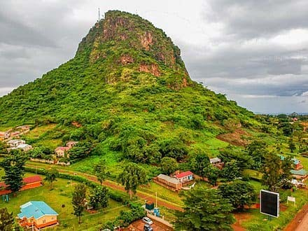

1. Basing on the knowledge obtained from studying photographs; identify the type of photograph seen in the photograph above. (02 mark)
2. Draw a landscape sketch of the area shown on the photograph and on it mark and name two physical features and man-made features. (08 marks)

2. Mr. Intellectual was reading a geography text book and he came across a certain diagram with different symbols! He wondered which kind of a diagram it could be. As a cartographer;

**Support material**

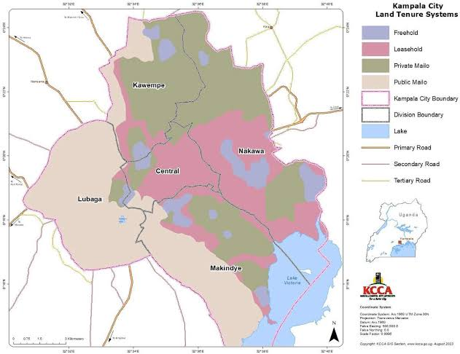

a) i) What diagram did Mr. Intellectual wonder about? (01 mark)

………………………………………………………………………………………..………

ii) Define for Mr. Intellectual the diagram he wondered about. (01 mark)

………………………………………………………………………………………………..

………………………………………………………………………..………………………

**b) Study the map below and answer questions that follow;**

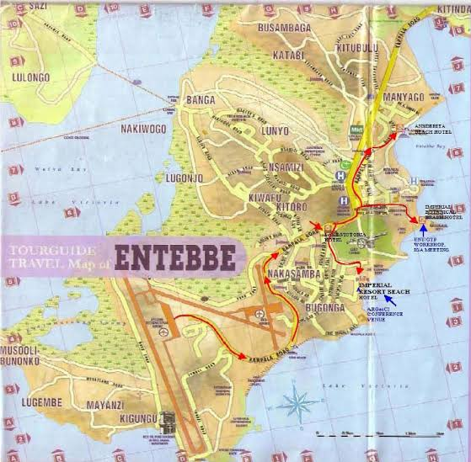

**Tasks**

1. What could be appropriate title for the map above? (01 mark)

………………………………………………………………………………………………………………………………………………………………………………………………

1. Using knowledge and skills from showing a local area on a map re-draw the map above in space provided below following features of a good map. And on it mark and name the following;
2. Nakiwogo and kigungu landing sites.
3. Swamp from Musooli Bunonko to lugonjo East of Nsamizi.
4. Entebbe airport (06 marks)
5. Design a key with clear symbols to represent features shown on the map in a square box of 10 by 10 cm. (03 marks)

**Space for drawing a sketch map**

3. It is important to record elements of weather such as rainfall, temperature and sunshine and this is done on a weather station.

**Support material**

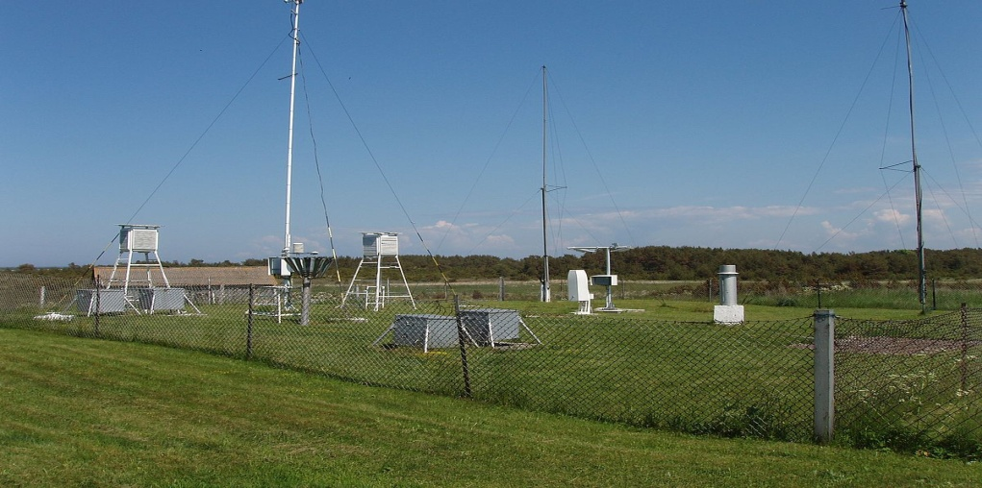

**Tasks**

i) State any **four** characteristics of a good weather station. (04 marks)

………………………………………………………………………………………………………………………………………………………………………………………………………………………………………………………………………………………………………………………………………………………………………………………………………………………………………………………………………………………………………………………………………………………………………………………………………………………………………………

ii) A Stevenson screen is a specially designed box on stands for keeping some of weather recording instruments. One of important features of a stevenson screen is that it should be **made of wood**. Mention any other **four** features it should possess. (04 marks)

………………………………………………………………………………………………………

………………………………………………………………………………………………………………………………………………………………………………………………………………………………………………………………………………………………………………………………………………………………………………………………………………………………

iii) State any **two** reasons why it is important to measure and record weather conditions apart from **weather forecasting** to a community. (02 marks)

………………………………………………………………………………………………………………………………………………………………………………………………………………………………………………………………………………………………………………………………………………………………………………………………………………………………

**-END-**

**SUCCESS & NICE HOLIDAYS**